
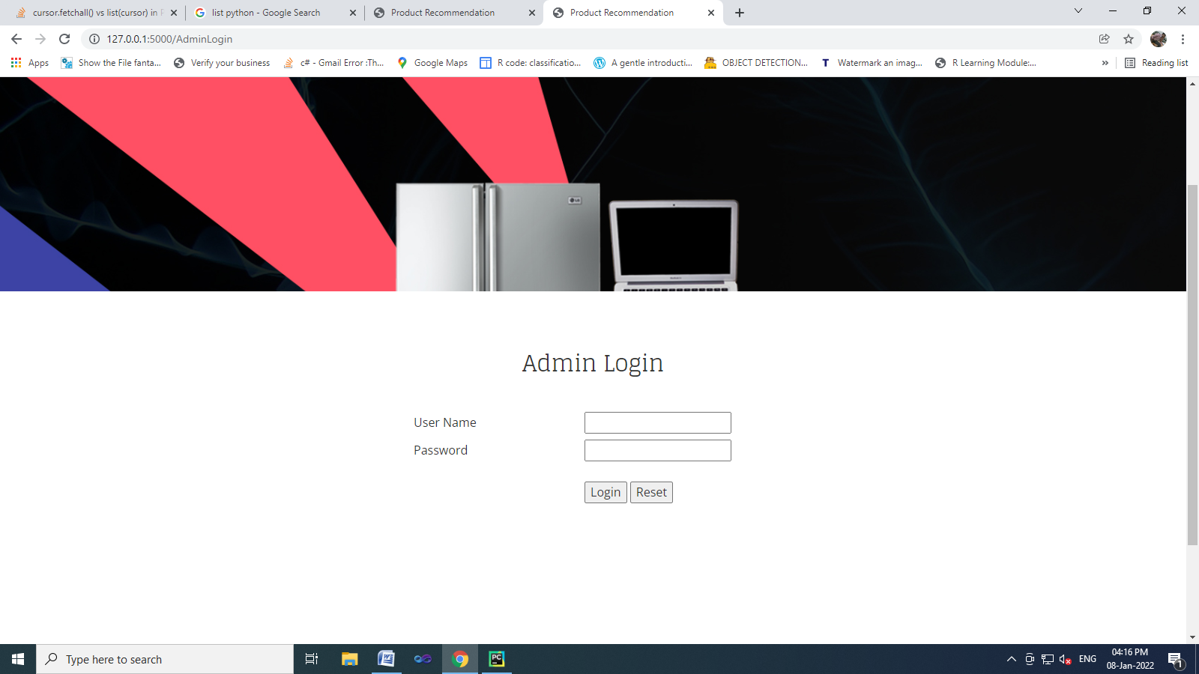
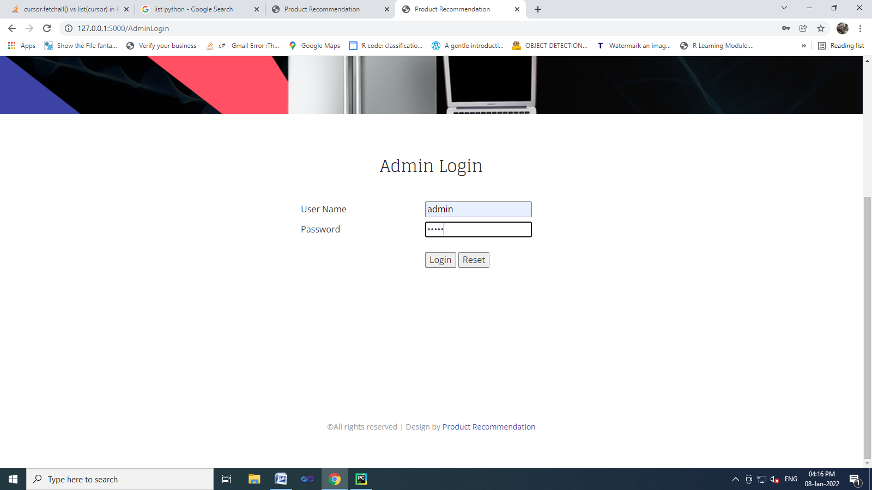
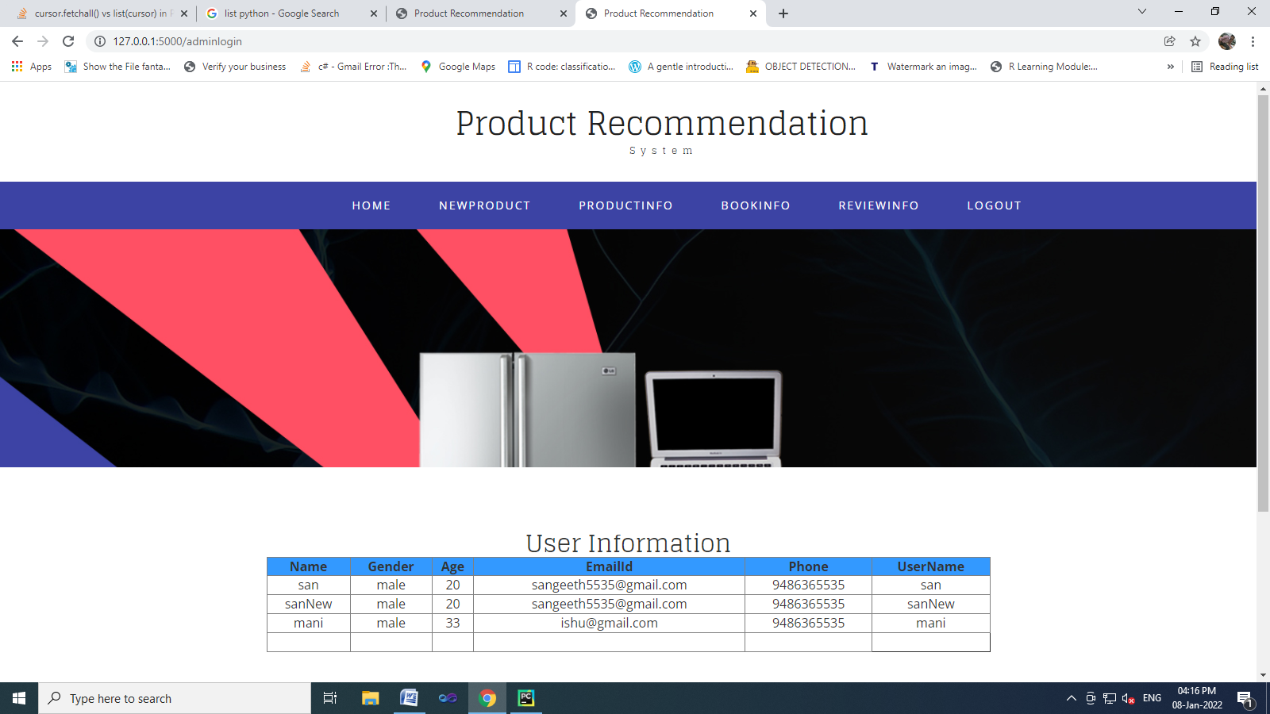
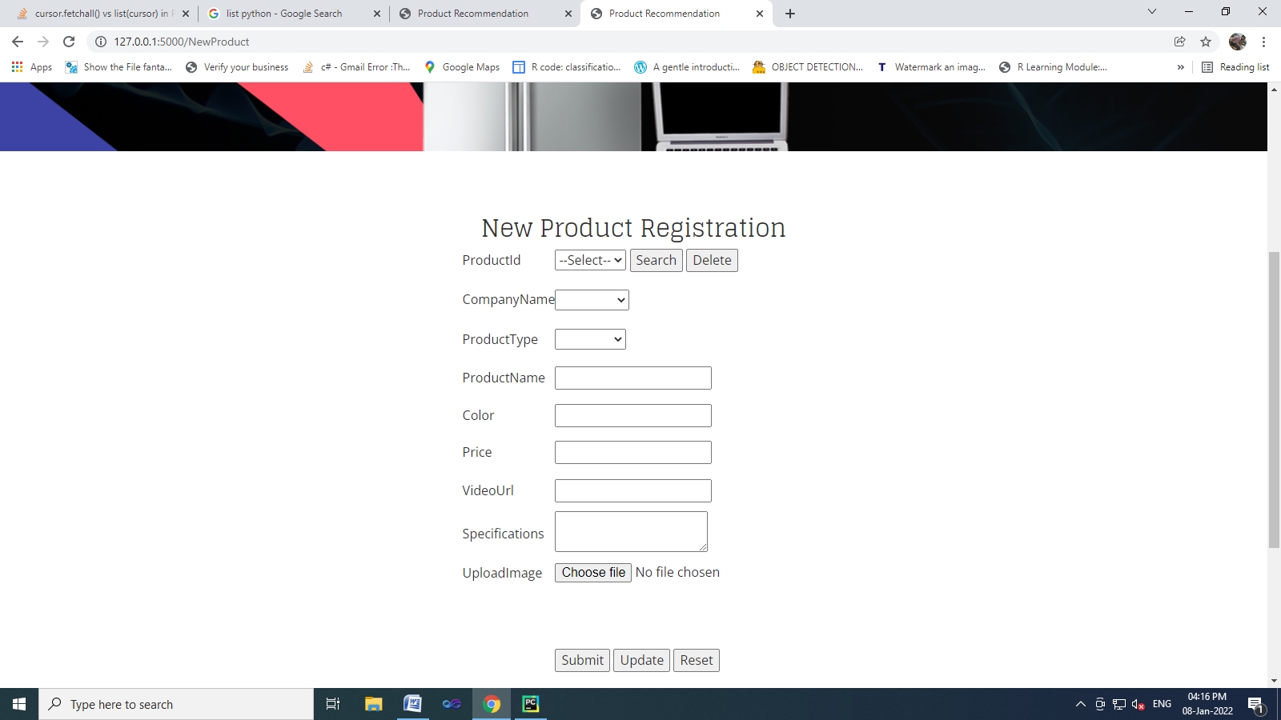
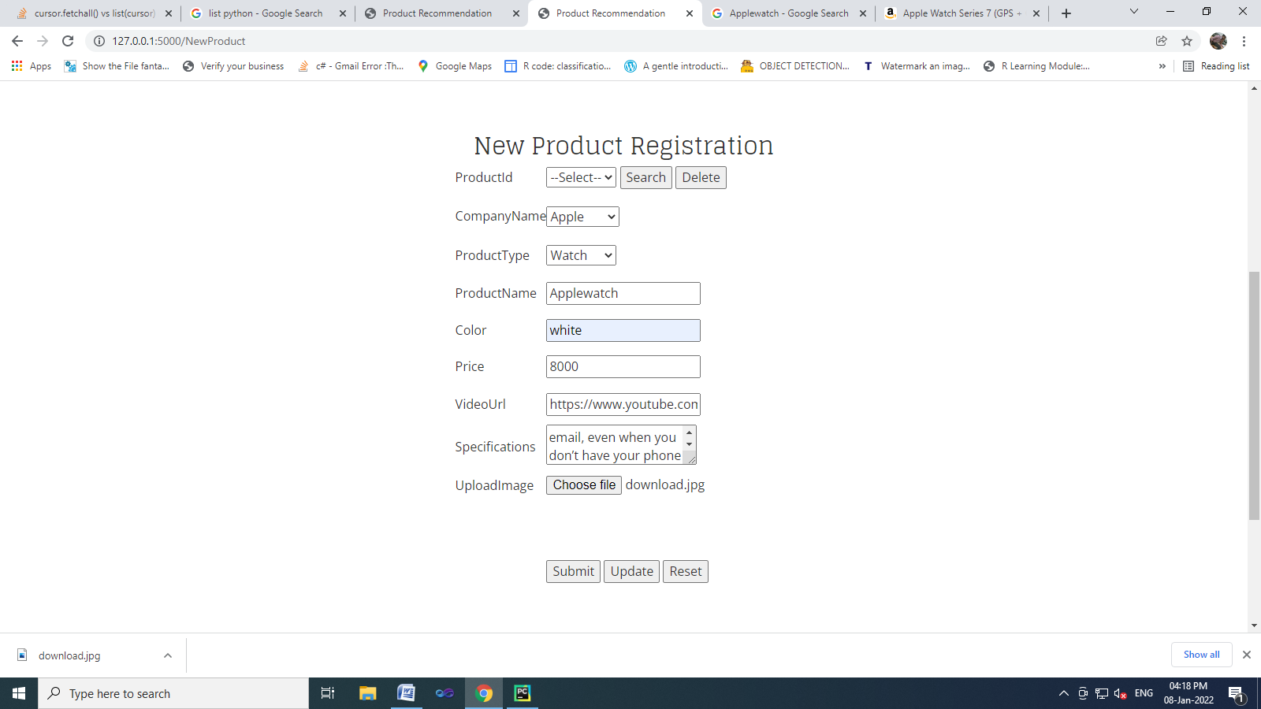
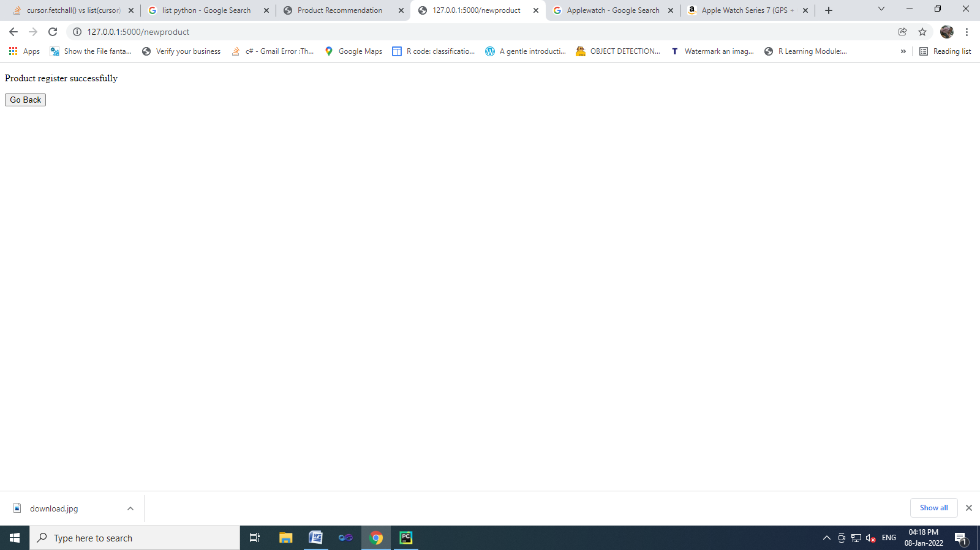
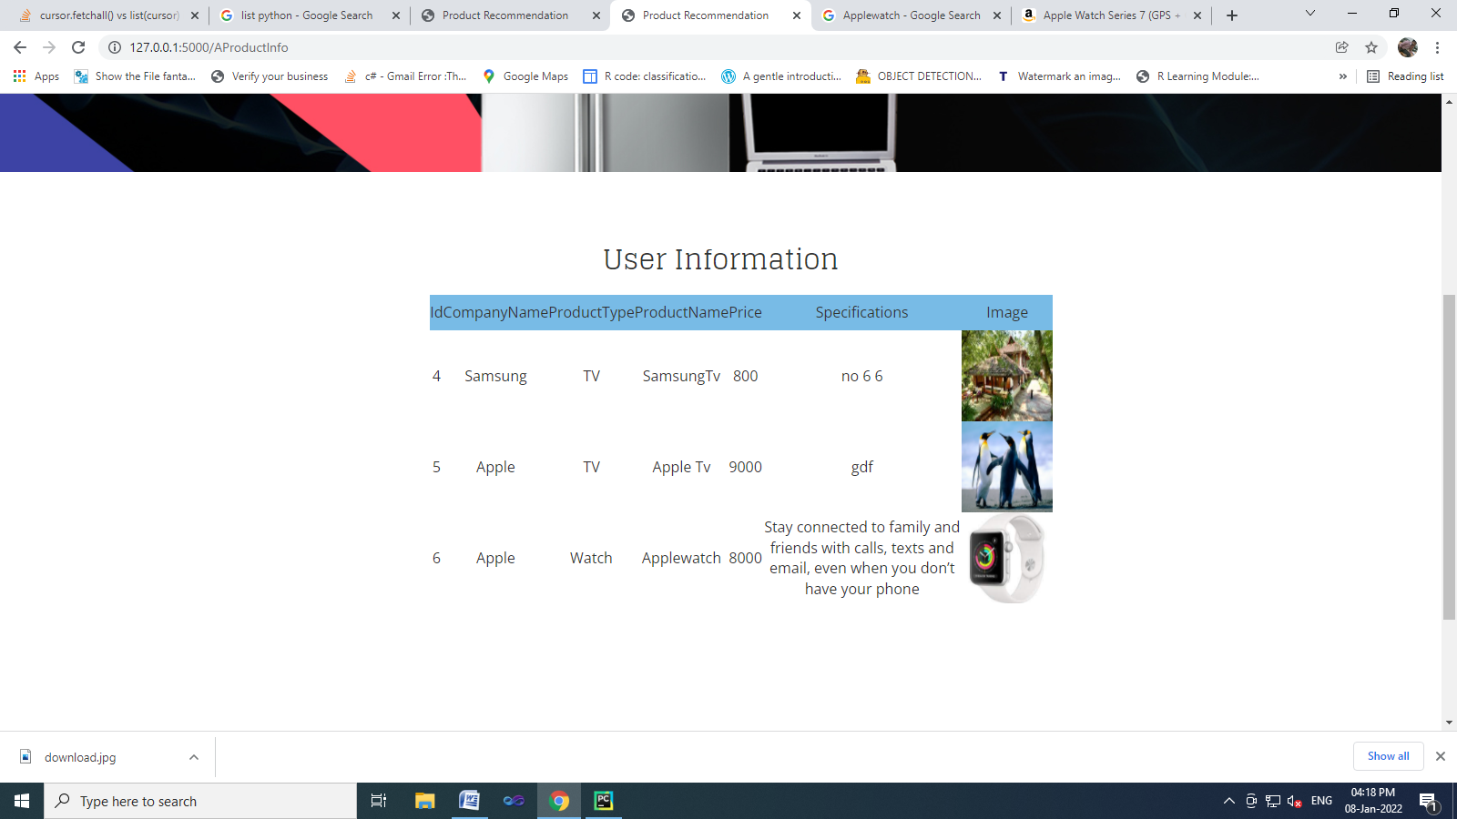
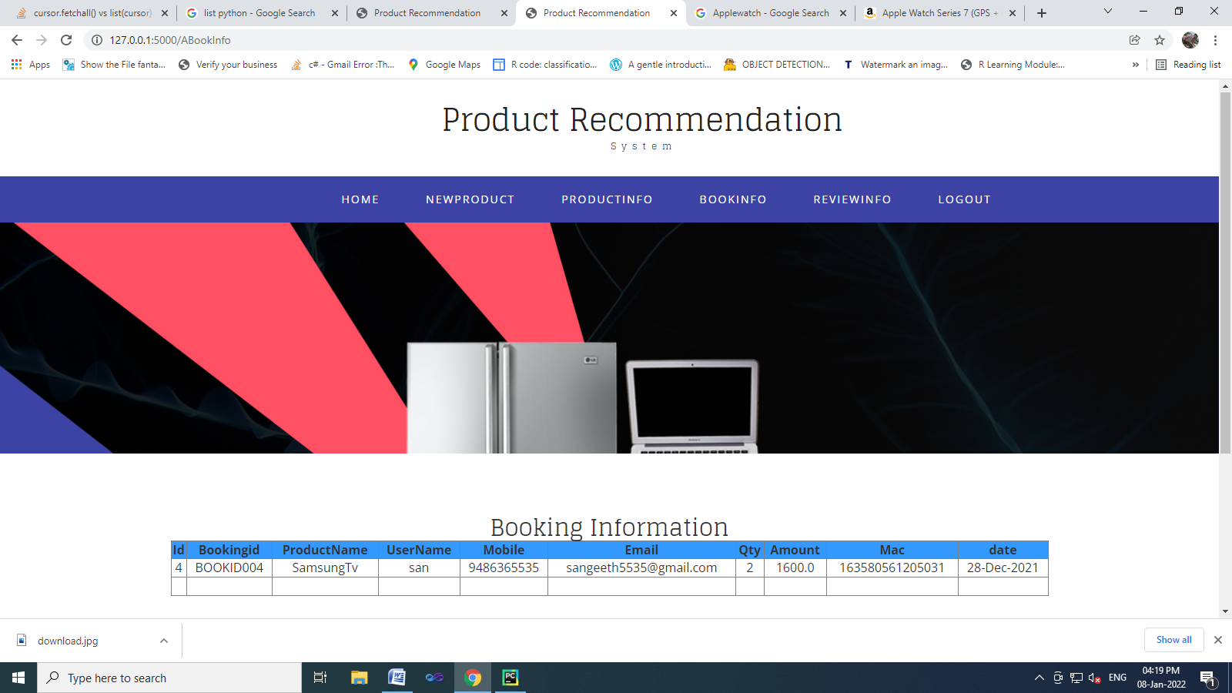
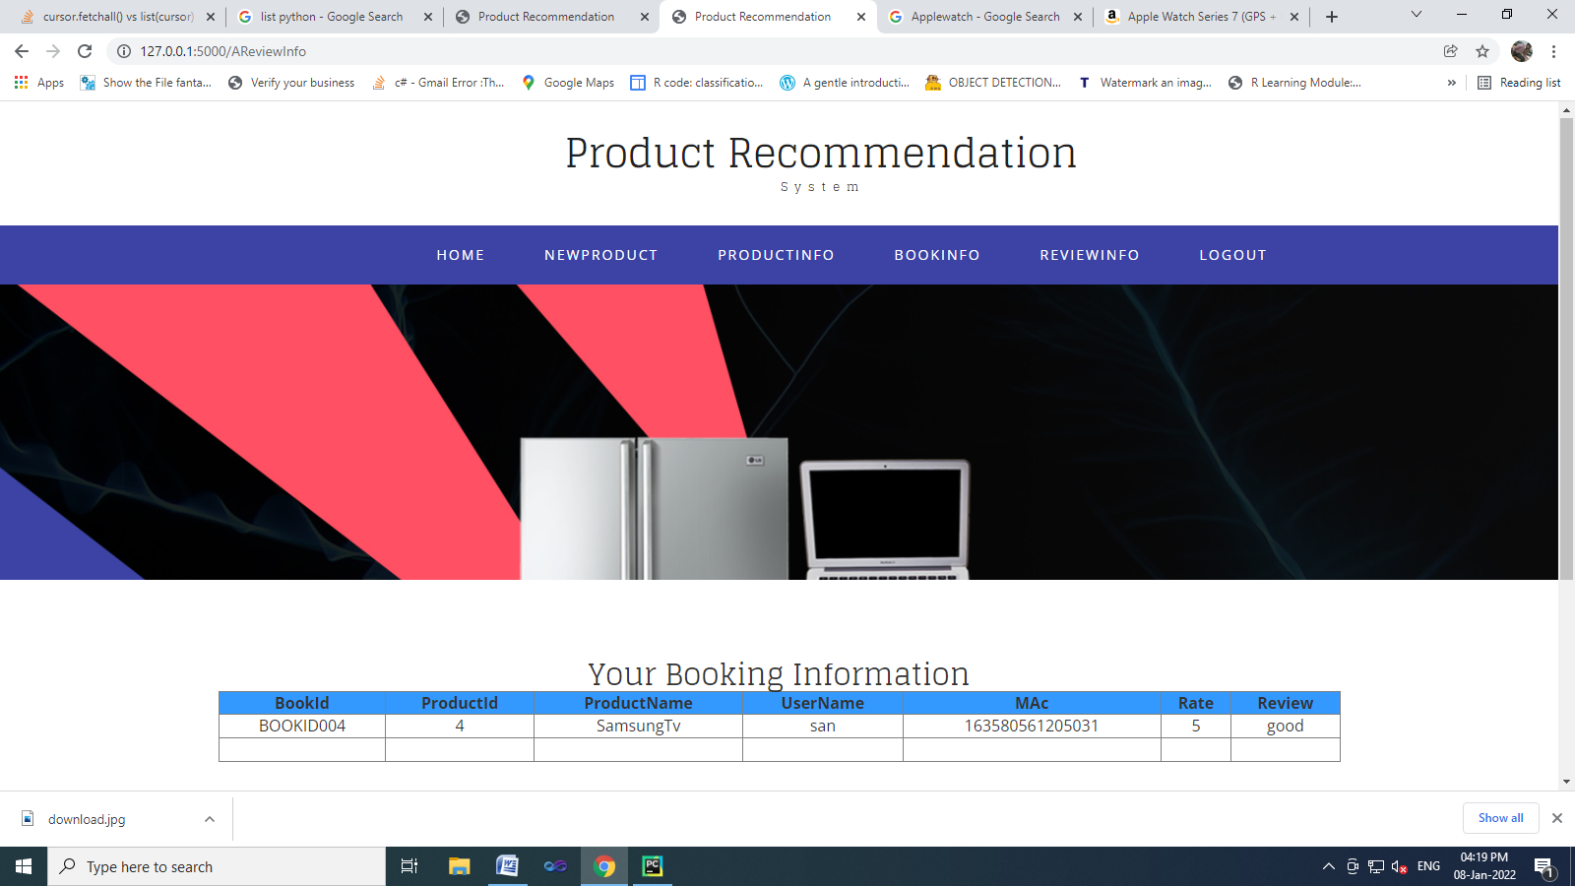
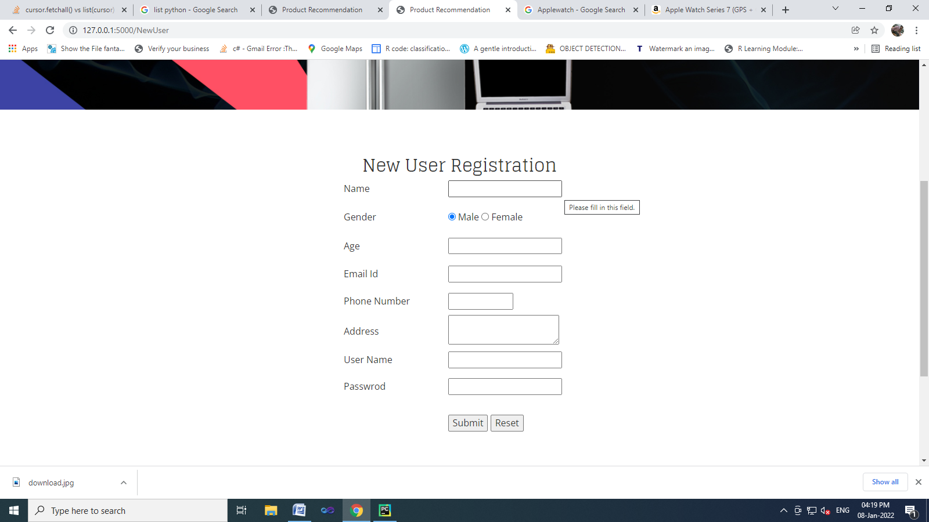
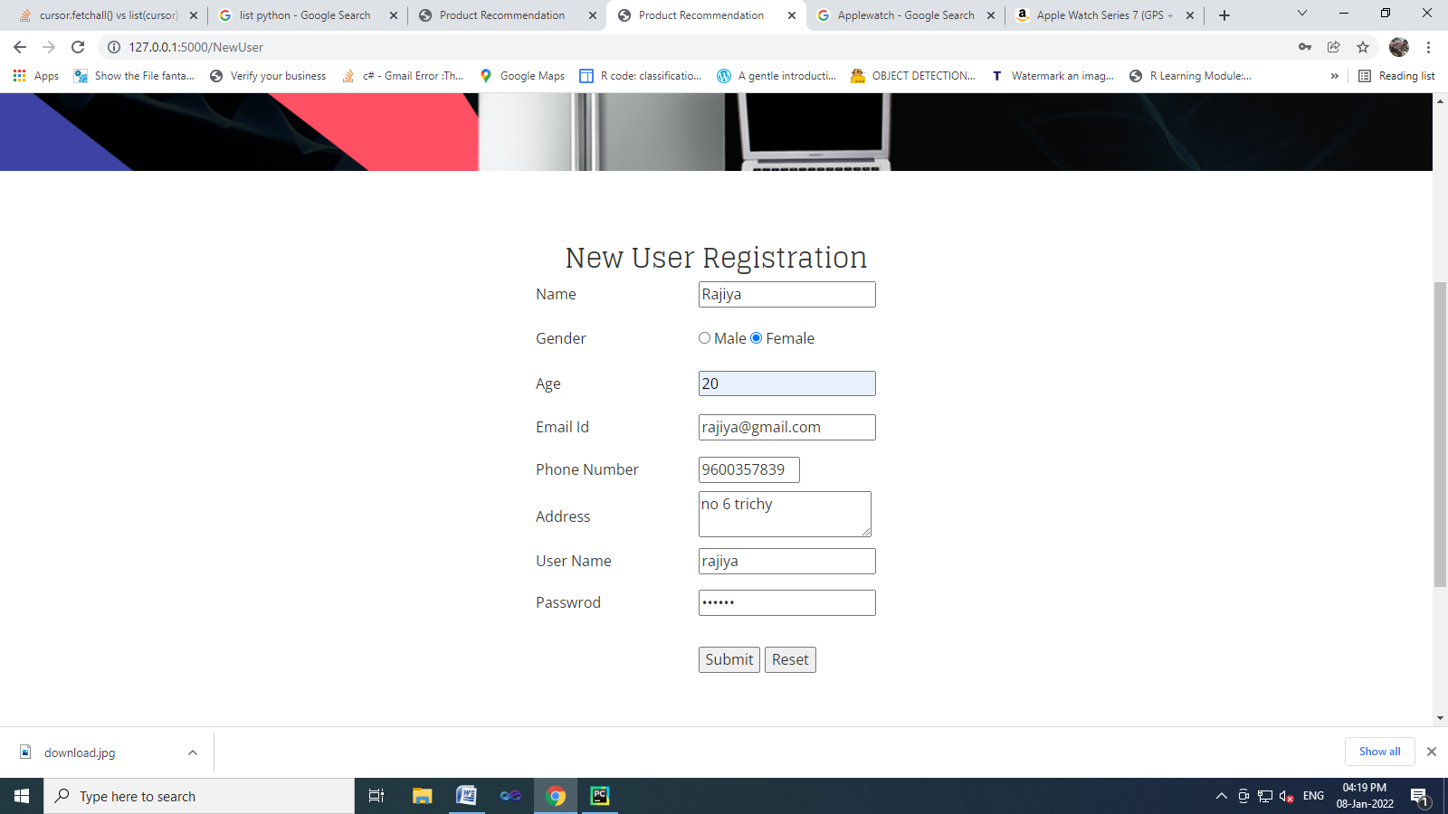

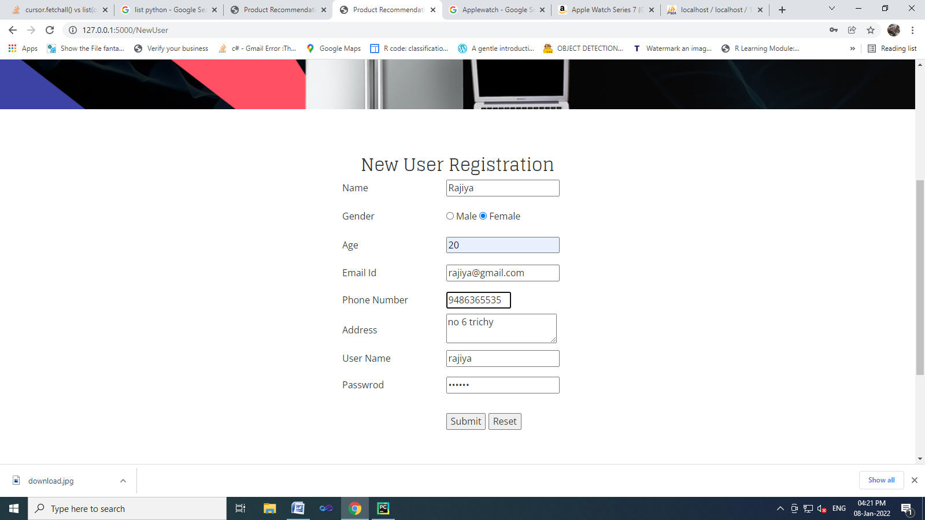

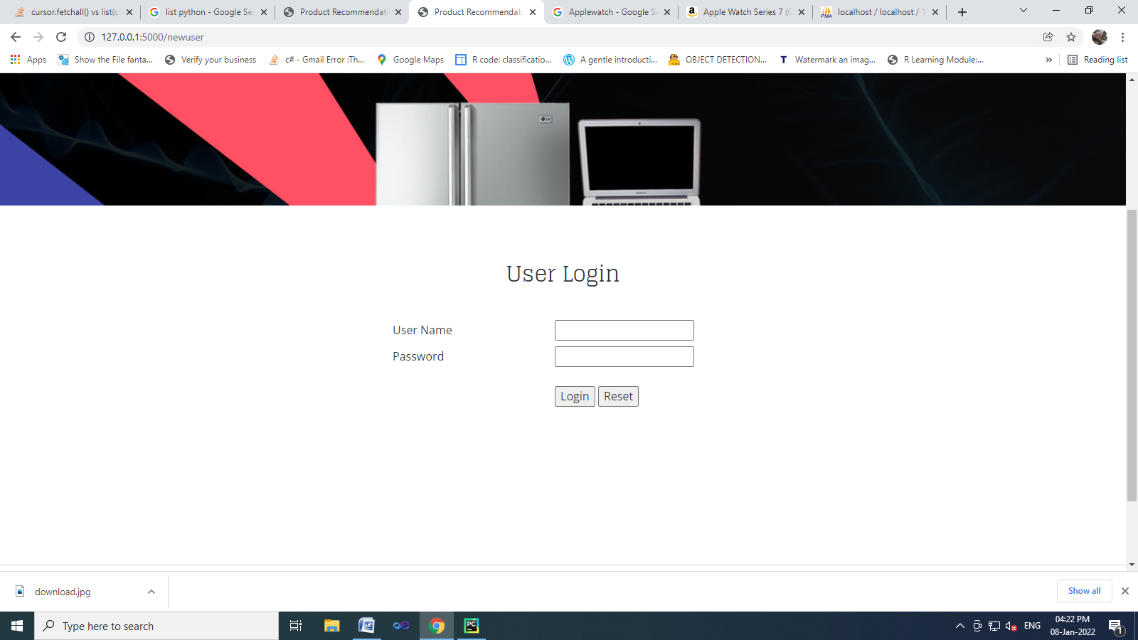
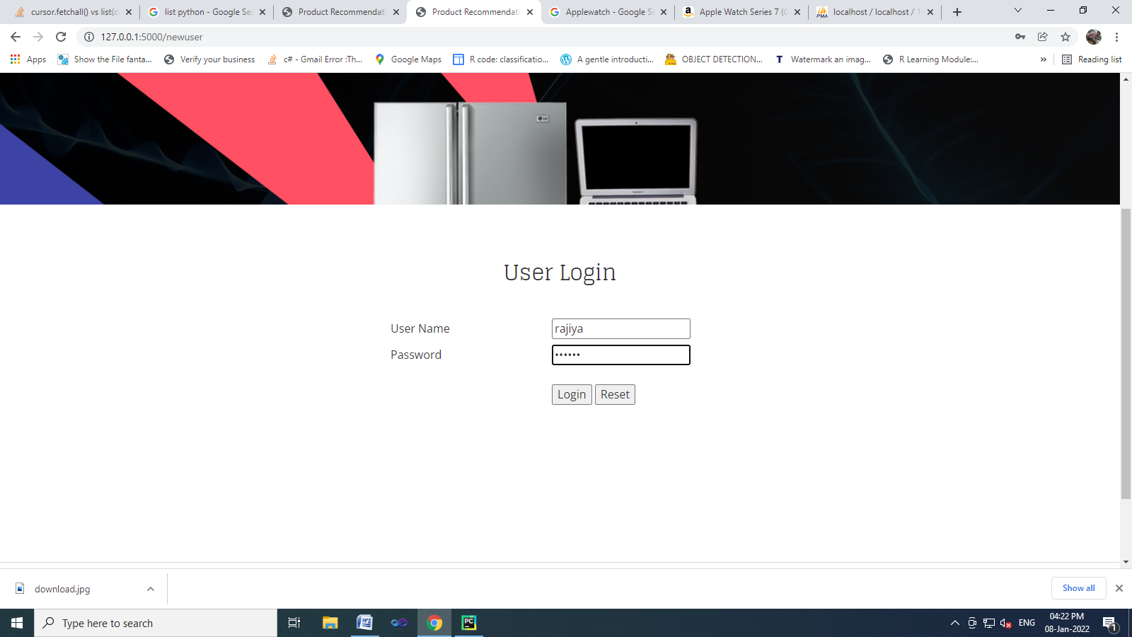
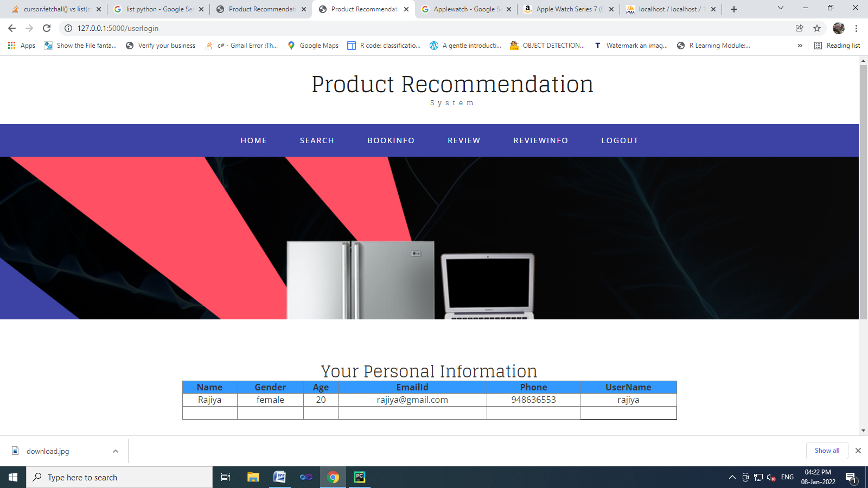
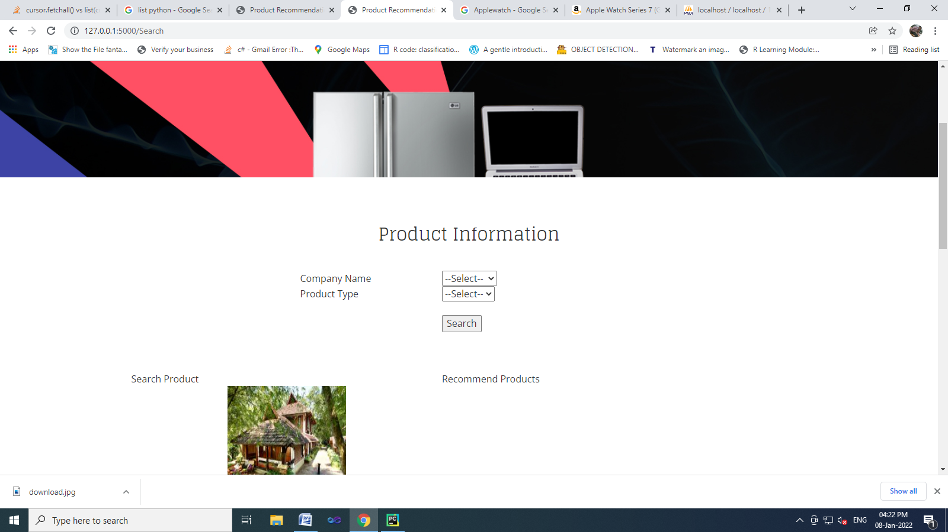
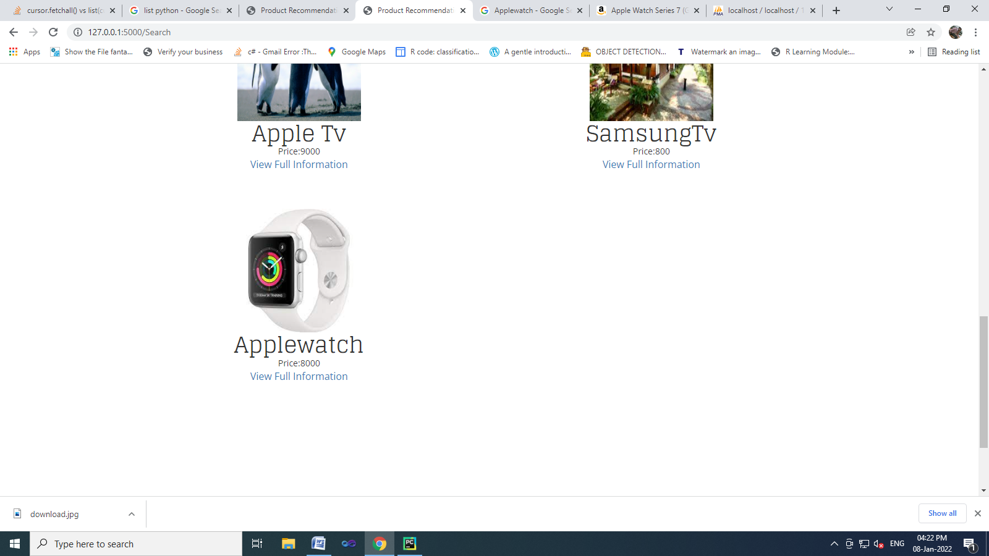
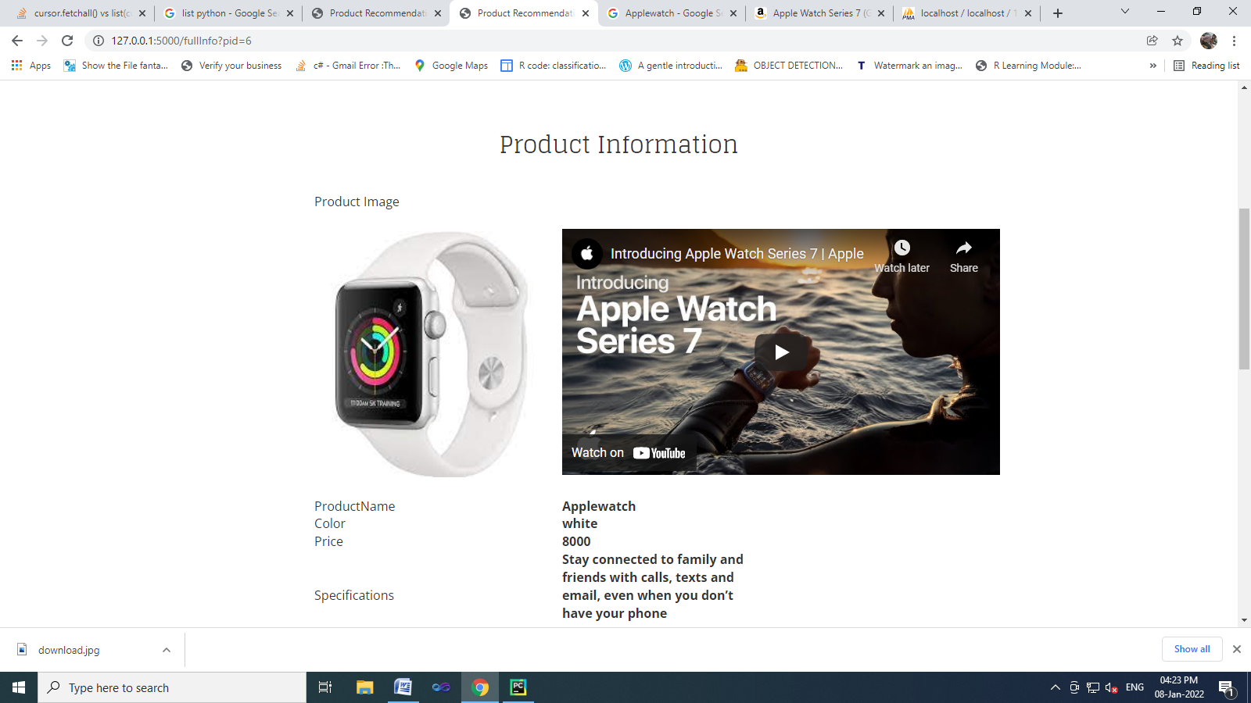
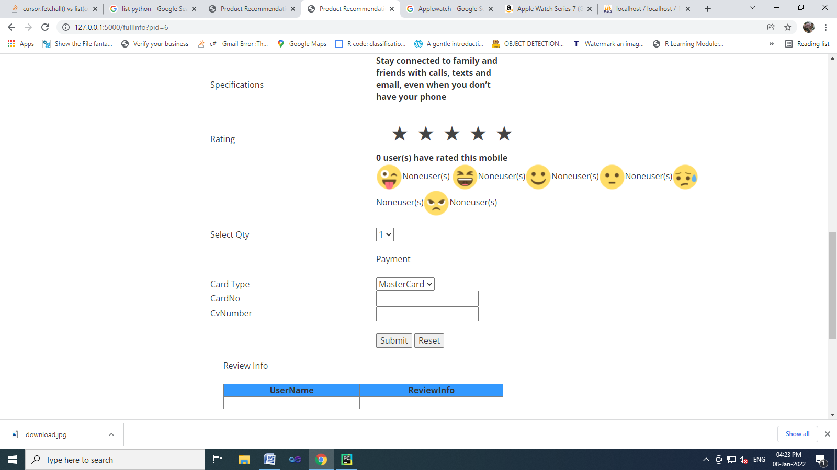
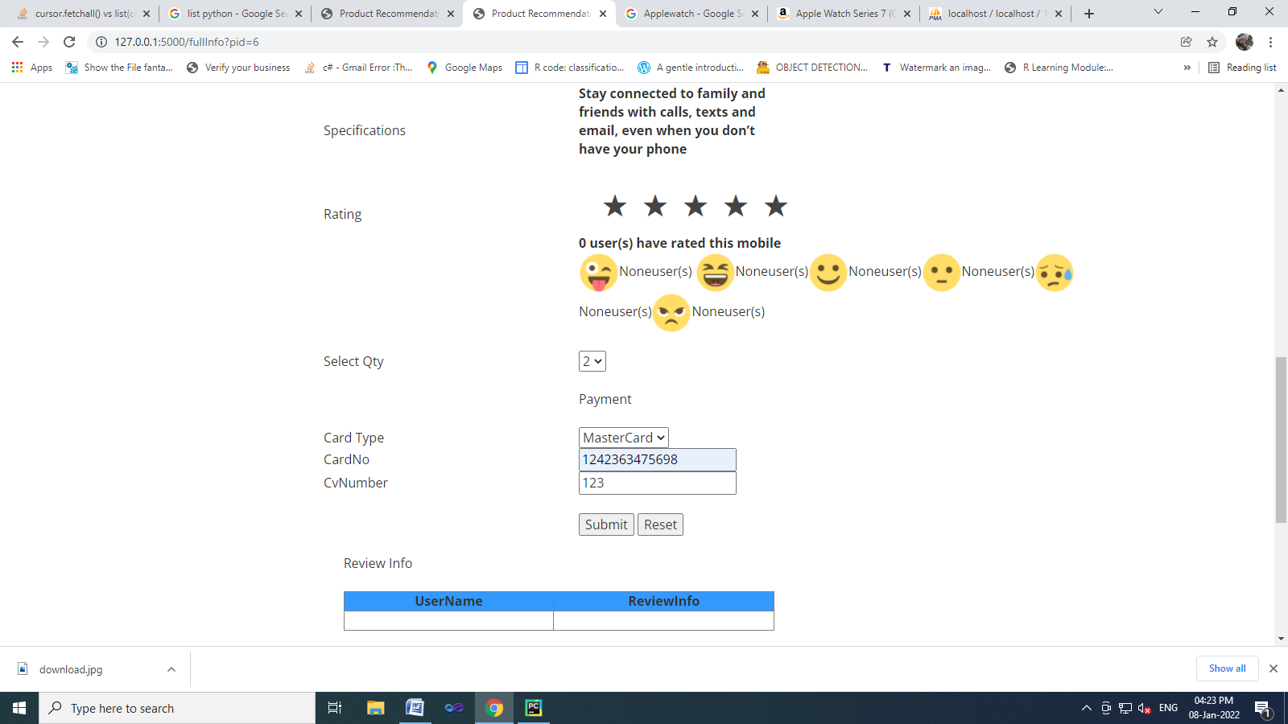
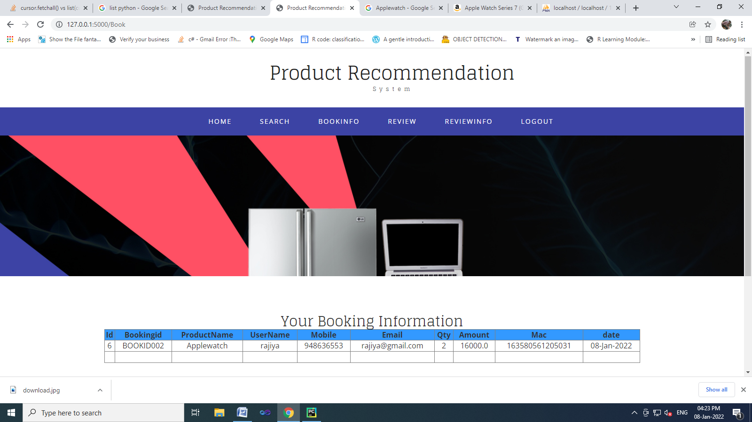
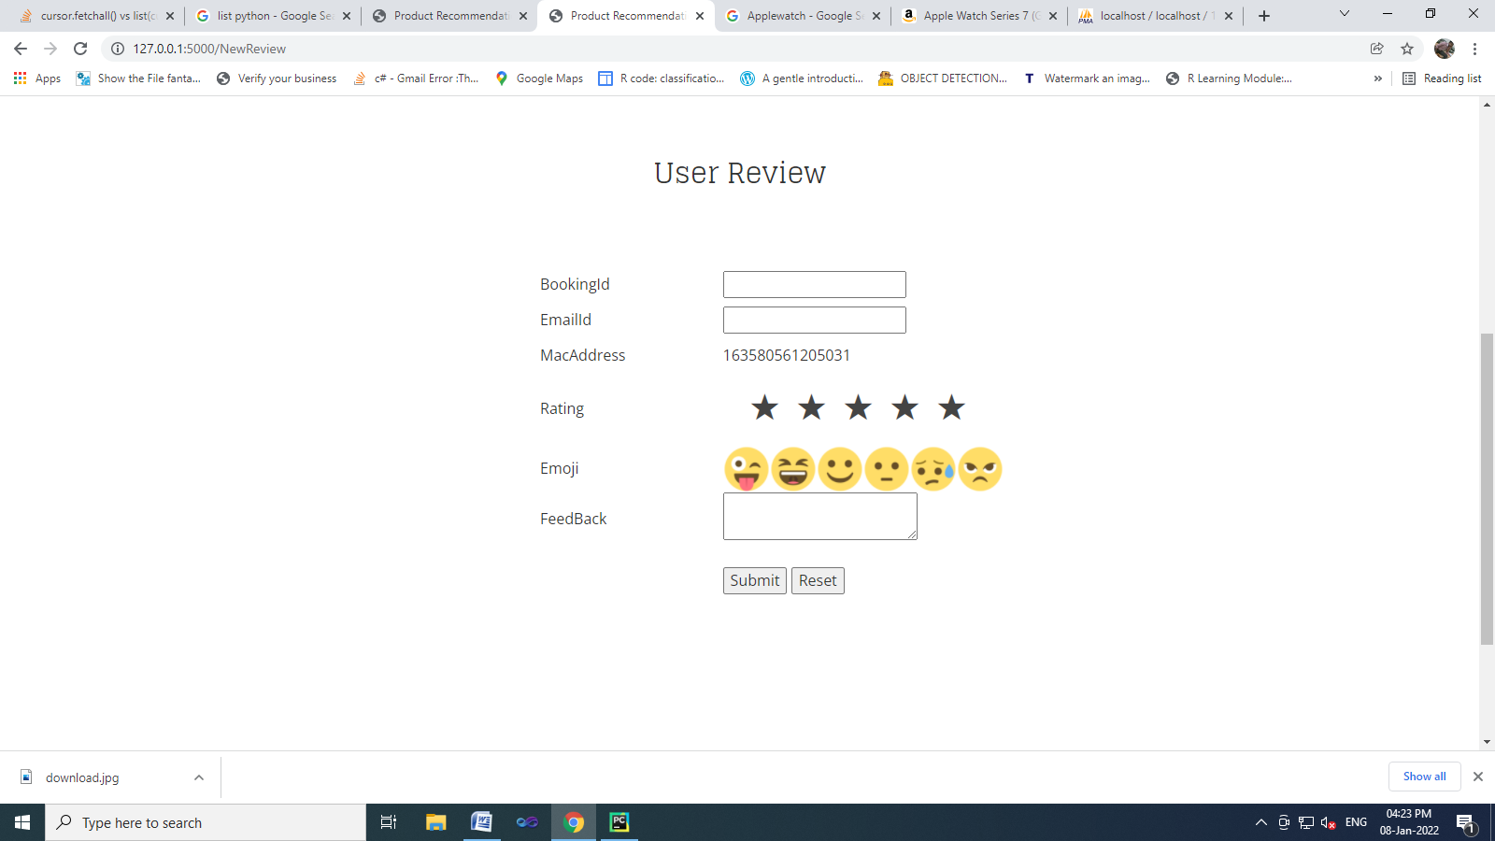
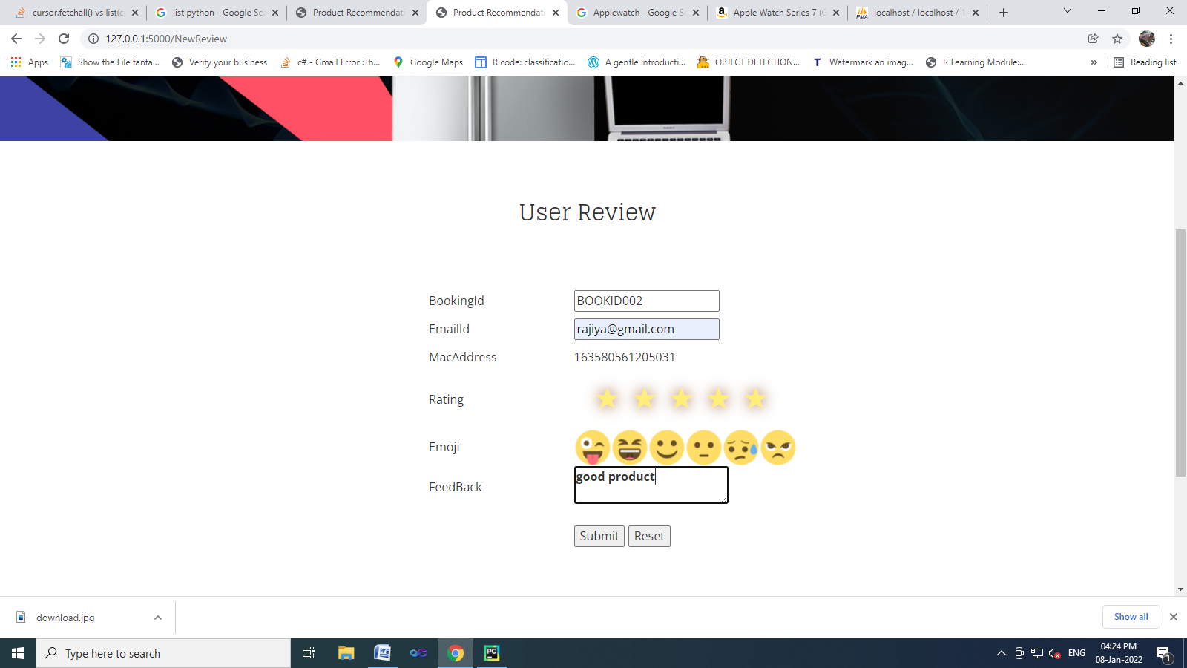
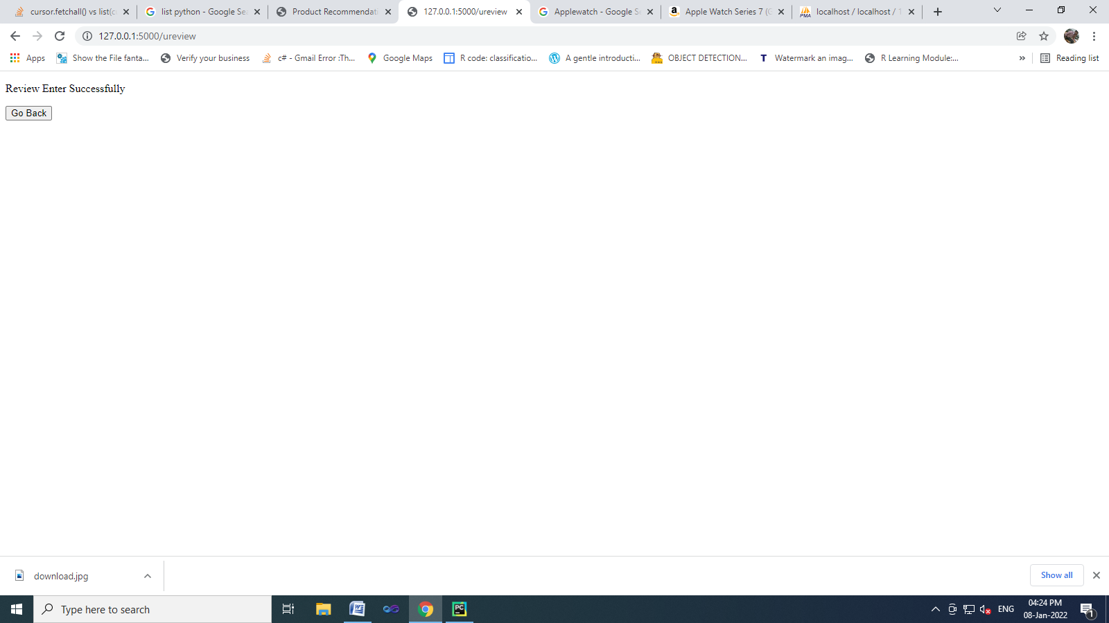
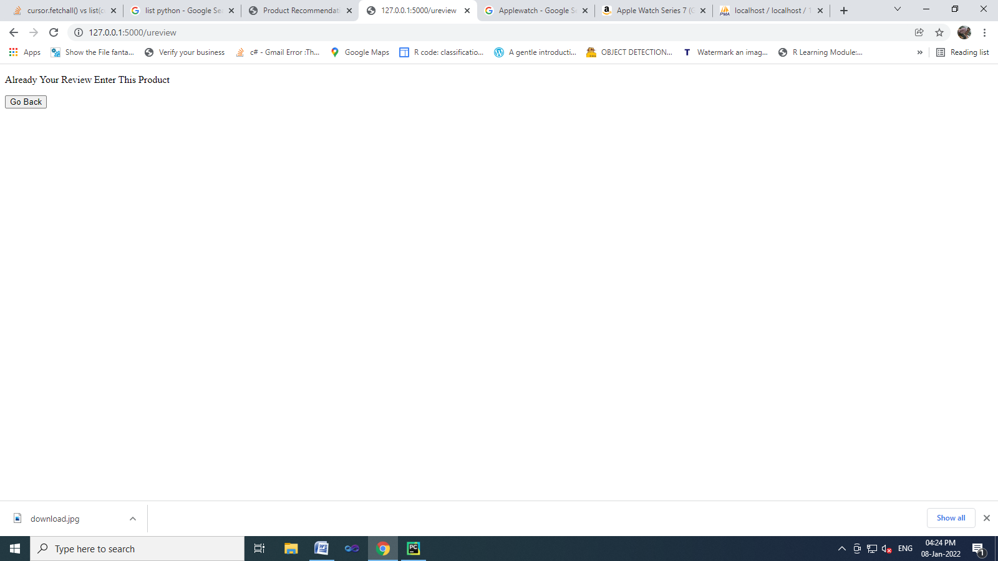
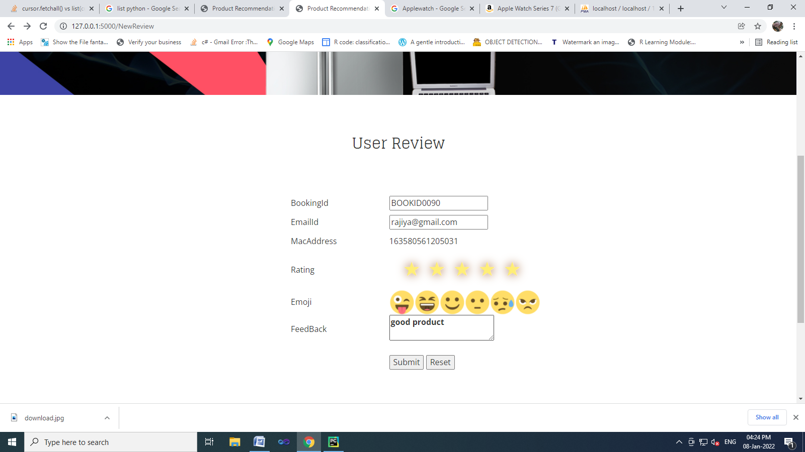
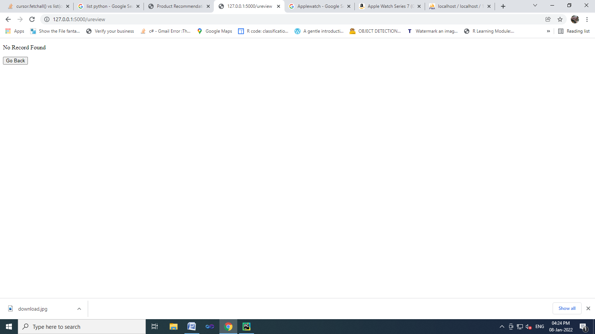
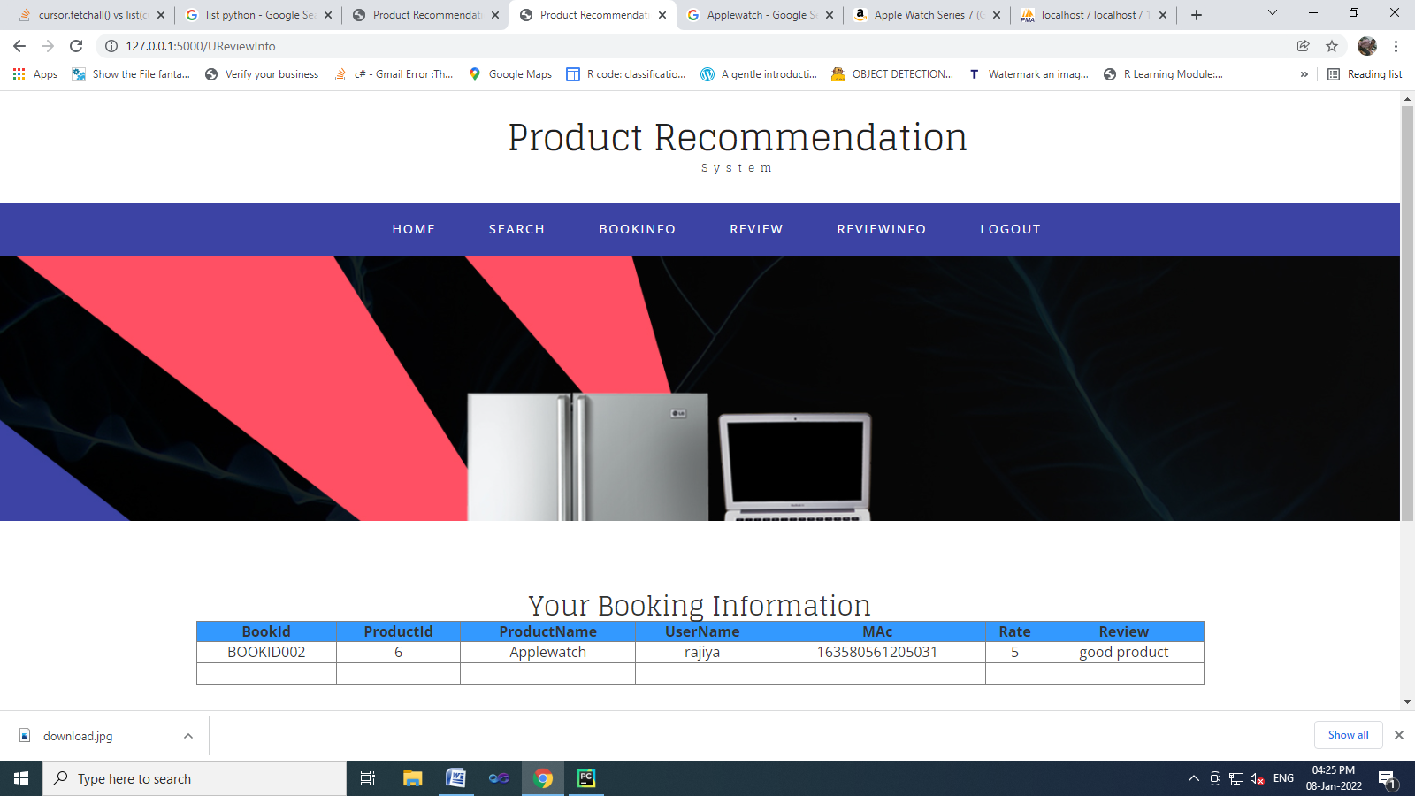

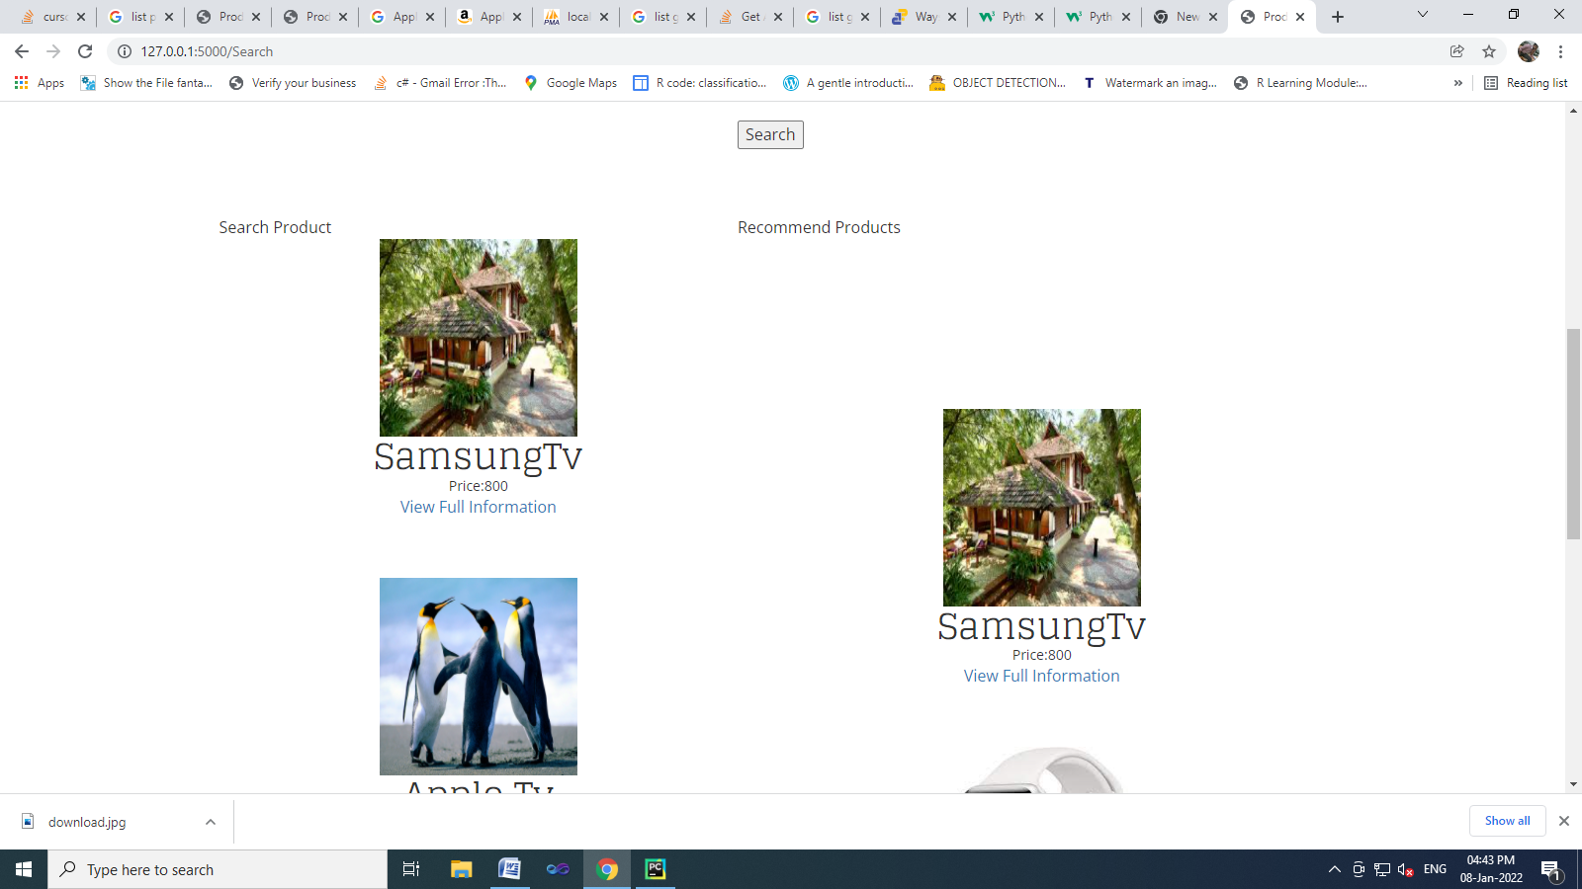
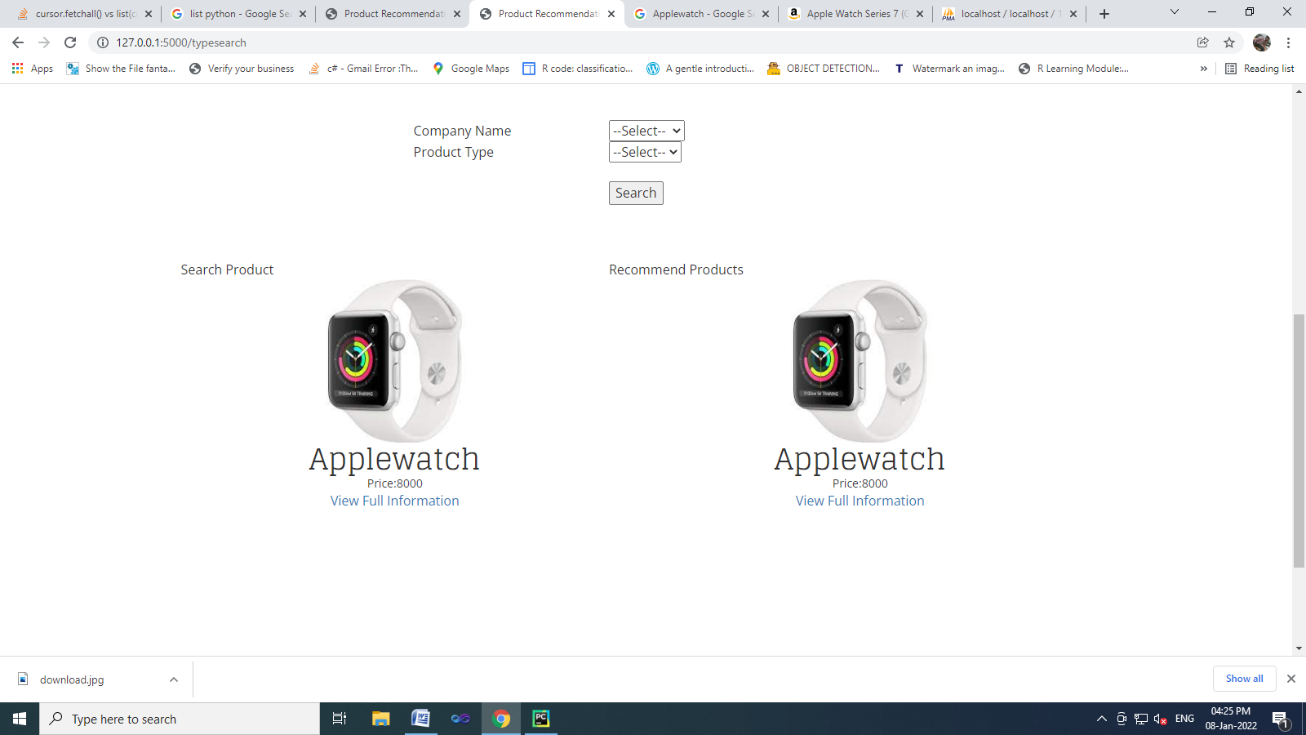
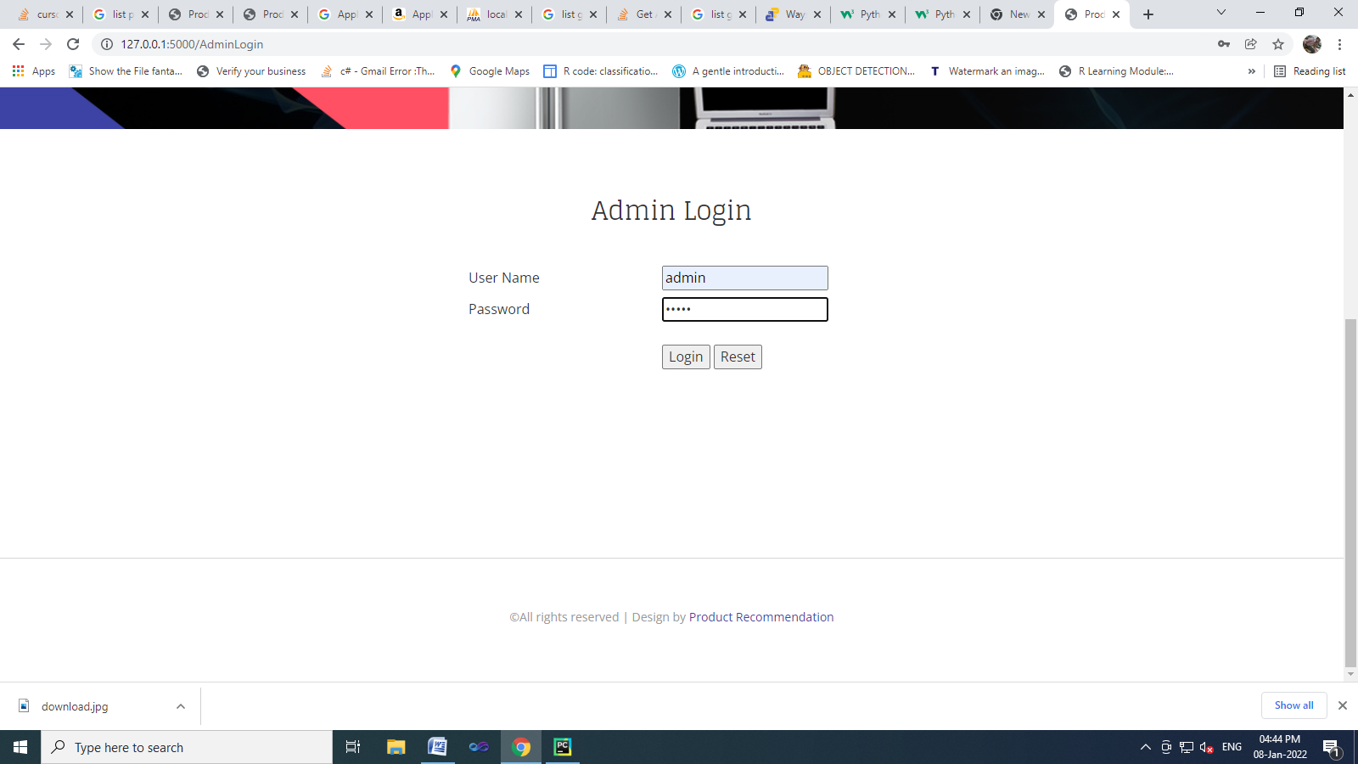
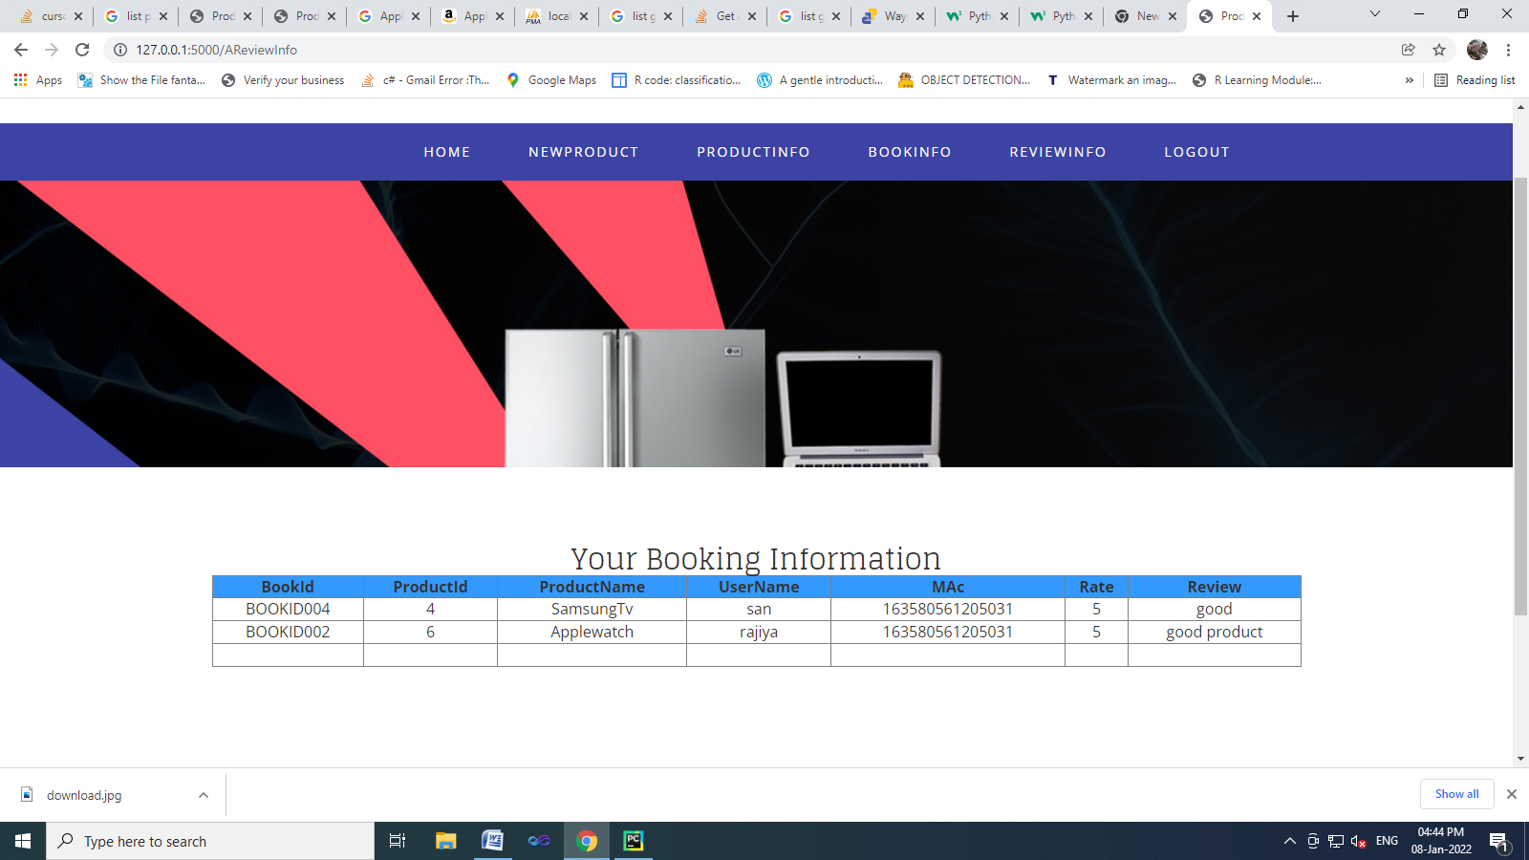
from flask import Flask, render_template, flash, request, session,send_file
from flask import render_template, redirect, url_for, request
#from wtforms import Form, TextField, TextAreaField, validators, StringField, SubmitField
from werkzeug.utils import secure_filename
import datetime
import mysql.connector
from nltk.corpus import stopwords
from nltk.tokenize import word_tokenize
import sys
app = Flask(__name__)
app.config['DEBUG']
app.config['SECRET_KEY'] = '7d441f27d441f27567d441f2b6176a'
@app.route("/")
def homepage():
return render_template('index.html')
@app.route("/AdminLogin")
def AdminLogin():
return render_template('AdminLogin.html')
@app.route("/UserLogin")
def UserLogin():
return render_template('UserLogin.html')
@app.route("/NewUser")
def NewUser():
return render_template('NewUser.html')
@app.route("/AdminHome")
def AdminHome():
conn = mysql.connector.connect(user='root', password='', host='localhost', database='1productrecomdb')
# cursor = conn.cursor()
cur = conn.cursor()
cur.execute("SELECT * FROM regtb ")
data = cur.fetchall()
return render_template('AdminHome.html', data=data)
@app.route("/NewProduct")
def NewProduct():
conn = mysql.connector.connect(user='root', password='', host='localhost', database='1productrecomdb')
# cursor = conn.cursor()
cur = conn.cursor()
cur.execute("SELECT * FROM protb ")
data = cur.fetchall()
return render_template('NewProduct.html', data=data)
@app.route("/AProductInfo")
def AProductInfo():
conn = mysql.connector.connect(user='root', password='', host='localhost', database='1productrecomdb')
# cursor = conn.cursor()
cur = conn.cursor()
cur.execute("SELECT * FROM protb ")
data = cur.fetchall()
return render_template('AProductInfo.html', data=data)
@app.route("/adminlogin", methods=['GET', 'POST'])
def adminlogin():
error = None
if request.method == 'POST':
if request.form['uname'] == 'admin' and request.form['password'] == 'admin':
conn = mysql.connector.connect(user='root', password='', host='localhost', database='1productrecomdb')
# cursor = conn.cursor()
cur = conn.cursor()
cur.execute("SELECT * FROM regtb ")
data = cur.fetchall()
return render_template('AdminHome.html', data=data)
else:
alert = 'Username or Password is wrong'
return render_template('goback.html', data=alert)
@app.route("/newproduct1", methods=['GET', 'POST'])
def newproduct1():
if request.method == 'POST':
#cname = session['Cname']
Cname = request.form['Cname']
Ptype = request.form['Ptype']
Pname = request.form['Pname']
color = request.form['color']
price = request.form['price']
Uvideo = request.form['Uvideo']
spec = request.form['spec']
file = request.files['file']
file.save("static/upload/" + secure_filename(file.filename))
conn = mysql.connector.connect(user='root', password='', host='localhost', database='1productrecomdb')
cursor = conn.cursor()
cursor.execute(
"INSERT INTO protb VALUES ('','"+ Cname +"','" + Ptype + "','" + Pname + "','" + color + "','" + price + "','" + Uvideo + "','" + spec + "','" + file.filename + "')")
conn.commit()
conn.close()
alert = 'Product register successfully'
return render_template('goback.html',data=alert )
@app.route("/newproduct", methods=['GET', 'POST'])
def newproduct():
if request.method == 'POST':
if request.form["submit"] == "Submit":
Cname = request.form['Cname']
Ptype = request.form['Ptype']
Pname = request.form['Pname']
color = request.form['color']
price = request.form['price']
Uvideo = request.form['Uvideo']
spec = request.form['spec']
file = request.files['file']
file.save("static/upload/" + file.filename)
conn = mysql.connector.connect(user='root', password='', host='localhost', database='1productrecomdb')
cursor = conn.cursor()
cursor.execute(
"INSERT INTO protb VALUES ('','" + Cname + "','" + Ptype + "','" + Pname + "','" + color + "','" + price + "','" + Uvideo + "','" + spec + "','" + file.filename + "')")
conn.commit()
conn.close()
alert = 'Product register successfully'
return render_template('goback.html', data=alert)
elif request.form["submit"] == "Update":
Pid = request.form['Pid']
Cname = request.form['Cname']
Ptype = request.form['Ptype']
Pname = request.form['Pname']
color = request.form['color']
price = request.form['price']
Uvideo = request.form['Uvideo']
spec = request.form['spec']
conn = mysql.connector.connect(user='root', password='', host='localhost', database='1productrecomdb')
cursor = conn.cursor()
cursor.execute(
"update protb set CompanyName ='" + Cname + "',ProductType='" + Ptype + "',ProductName='" + Pname + "',Color='" + color + "',Price='" + price + "',VideoUrl='" + Uvideo + "',Specifications='" + spec + "' where id='"+Pid+"' ")
conn.commit()
conn.close()
alert = 'Record Updated!'
return render_template('goback.html', data=alert)
elif request.form["submit"] == "Search":
Pid = request.form['Pid']
conn = mysql.connector.connect(user='root', password='', host='localhost', database='1productrecomdb')
# cursor = conn.cursor()
cur = conn.cursor()
cur.execute("SELECT * FROM protb where id='"+ Pid +"' ")
data = cur.fetchone()
if data:
Cname = data[1]
Ptype = data[2]
Pname = data[3]
color = data[4]
price = data[5]
Uvideo = data[6]
spec = data[7]
conn = mysql.connector.connect(user='root', password='', host='localhost', database='1productrecomdb')
# cursor = conn.cursor()
cur = conn.cursor()
cur.execute("SELECT * FROM protb ")
data = cur.fetchall()
return render_template('Newproduct.html', data=data,Cname=Cname,Ptype=Ptype,Pname=Pname,color=color,price=price,Uvideo=Uvideo,spec=spec)
else:
return 'Incorrect username / password !'
elif request.form["submit"] == "Delete":
Pid = request.form['Pid']
conn = mysql.connector.connect(user='root', password='', host='localhost', database='1productrecomdb')
cursor = conn.cursor()
cursor.execute(
"delete from protb where id='" + Pid + "' ")
conn.commit()
conn.close()
alert = 'Record Deleted!'
return render_template('goback.html', data=alert)
return render_template('goback.html')
@app.route("/newuser", methods=['GET', 'POST'])
def newuser():
if request.method == 'POST':
name1 = request.form['name']
gender1 = request.form['gender']
Age = request.form['age']
email = request.form['email']
pnumber = request.form['phone']
address = request.form['address']
uname = request.form['uname']
password = request.form['psw']
conn = mysql.connector.connect(user='root', password='', host='localhost', database='1productrecomdb')
cursor = conn.cursor()
cursor.execute(
"INSERT INTO regtb VALUES ('" + name1 + "','" + gender1 + "','" + Age + "','" + email + "','" + pnumber + "','" + address + "','" + uname + "','" + password + "')")
conn.commit()
conn.close()
# return 'file register successfully'
return render_template('UserLogin.html')
@app.route("/userlogin", methods=['GET', 'POST'])
def userlogin():
error = None
if request.method == 'POST':
username = request.form['uname']
password = request.form['password']
session['uname'] = request.form['uname']
conn = mysql.connector.connect(user='root', password='', host='localhost', database='1productrecomdb')
cursor = conn.cursor()
cursor.execute("SELECT * from regtb where username='" + username + "' and Password='" + password + "'")
data = cursor.fetchone()
if data is None:
alert = 'Username or Password is wrong'
return render_template('goback.html', data=alert)
else:
conn = mysql.connector.connect(user='root', password='', host='localhost', database='1productrecomdb')
# cursor = conn.cursor()
cur = conn.cursor()
cur.execute("SELECT * FROM regtb where username='" + username + "' and Password='" + password + "'")
data = cur.fetchall()
return render_template('UserHome.html', data=data )
def recommend():
# 'Recommend'
neg = 0
pas = 0
conn = mysql.connector.connect(user='root', password='', host='localhost', database='1productrecomdb')
cursor = conn.cursor()
cursor.execute("Truncate table temptb")
conn.commit()
conn.close()
conn = mysql.connector.connect(user='root', password='', host='localhost', database='1productrecomdb')
cur = conn.cursor()
cur.execute("SELECT ProductId,Image,ProductName,Price FROM reviewtb where Result='Postive' ")
data1 = cur.fetchall()
for row in data1:
conn = mysql.connector.connect(user='root', password='', host='localhost', database='1productrecomdb')
cursor = conn.cursor()
cursor.execute(
"SELECT count(*) as count FROM reviewtb WHERE ProductId ='" + row[0] + "' and Result='Postive' ")
data2 = cursor.fetchone()
if data2:
pas = data2[0]
else:
pas = 0
conn = mysql.connector.connect(user='root', password='', host='localhost', database='1productrecomdb')
cursor = conn.cursor()
cursor.execute(
"SELECT count(*) as count FROM reviewtb WHERE ProductId ='" + row[0] + "' and Result='negative' ")
data3 = cursor.fetchone()
if data3:
neg = data3[0]
else:
neg = 0
if pas >= neg:
conn = mysql.connector.connect(user='root', password='', host='localhost', database='1productrecomdb')
cur = conn.cursor()
cur.execute(
"SELECT ProductId,CompanyName,ProductType,ProductName,Price,Image FROM reviewtb where ProductId ='" + row[0] + "' ")
data22 = cur.fetchone()
if data22:
s1 = data22[0]
s2 = data22[1]
s3 = data22[2]
s4 = data22[3]
s5 = data22[4]
s6 = data22[5]
else:
neg = 0
conn = mysql.connector.connect(user='root', password='', host='localhost', database='1productrecomdb')
cursor = conn.cursor()
cursor.execute(
"insert into temptb values('" + s1 + "','" + s2 + "','" + s3 + "','" + s4 + "','" + s5 + "','" + s6 + "')")
conn.commit()
conn.close()
@app.route("/Search")
def Search():
recommend()
conn = mysql.connector.connect(user='root', password='', host='localhost', database='1productrecomdb')
cur = conn.cursor()
cur.execute("SELECT * FROM protb ")
data = cur.fetchall()
conn = mysql.connector.connect(user='root', password='', host='localhost', database='1productrecomdb')
cur = conn.cursor()
cur.execute("SELECT ProductId,Image,ProductName,Price FROM temptb ")
data1 = cur.fetchall()
return render_template('Search.html',data=data , data1=data1 )
@app.route("/typesearch", methods=['GET', 'POST'])
def typesearch():
cname = request.form['Cname']
ptype = request.form['Ptype']
conn = mysql.connector.connect(user='root', password='', host='localhost', database='1productrecomdb')
cursor = conn.cursor()
cursor.execute("SELECT * from protb where CompanyName='" + cname + "' and ProductType='" + ptype + "'")
data = cursor.fetchone()
if data is None:
alert = 'Product Not Found!'
return render_template('goback.html', data=alert)
else:
recommend()
conn = mysql.connector.connect(user='root', password='', host='localhost', database='1productrecomdb')
cur = conn.cursor()
cur.execute("SELECT * FROM protb where CompanyName='" + cname + "' and ProductType='" + ptype + "' ")
data = cur.fetchall()
conn = mysql.connector.connect(user='root', password='', host='localhost', database='1productrecomdb')
cur = conn.cursor()
cur.execute("SELECT ProductId,Image,ProductName,Price FROM temptb where CompanyName='" + cname + "' and ProductType='" + ptype + "' ")
data1 = cur.fetchall()
return render_template('Search.html', data=data, data1=data1)
@app.route("/fullInfo")
def fullInfo():
pid = request.args.get('pid')
session['pid'] = pid
rat1 = ''
rat2 = ''
rat3 = ''
rat4 = ''
rat5 = ''
conn = mysql.connector.connect(user='root', password='', host='localhost', database='1productrecomdb')
cursor = conn.cursor()
cursor.execute(
"SELECT ROUND(AVG(Rate), 1) as numRating FROM reviewtb WHERE ProductId ='" + pid + "' ")
data2 = cursor.fetchone()
print(data2[0])
if data2 is None:
avgrat = 0
else:
if data2[0] == 'None':
avgrat = 0
if (int(avgrat) == 1):
rat1 = 'checked'
if (int(avgrat) == 2):
rat2 = 'checked'
if (int(avgrat) == 3):
rat3 = 'checked'
if (int(avgrat) == 4):
rat4 = 'checked'
if (int(avgrat) == 5):
rat5 = 'checked'
else:
avgrat = data2[0]
if (avgrat == 1):
rat1 = 'checked'
if (avgrat == 2):
rat2 = 'checked'
if (avgrat == 3):
rat3 = 'checked'
if (avgrat == 4):
rat4 = 'checked'
if (avgrat == 5):
rat5 = 'checked'
conn = mysql.connector.connect(user='root', password='', host='localhost', database='1productrecomdb')
cursor = conn.cursor()
cursor.execute(
"SELECT count(Rate) as numRating FROM reviewtb WHERE ProductId ='" + pid + "' ")
data3 = cursor.fetchone()
if data3:
avgrat = data3[0]
else:
return 'Incorrect username / password !'
conn = mysql.connector.connect(user='root', password='', host='localhost', database='1productrecomdb')
cursor = conn.cursor()
cursor.execute("SELECT sum(Smile1) as count1,sum(Smile2) as count2, sum(Smile3) as count3, sum(Smile4) as count4, sum(Smile5) as count5, sum(Smile6) as count6 FROM reviewtb where ProductId='"+ pid +"' ")
data = cursor.fetchone()
if data:
smile1 = data[0]
smile2 = data[1]
smile3 = data[2]
smile4 = data[3]
smile5 = data[4]
smile6 = data[5]
else:
return 'Incorrect username / password !'
conn = mysql.connector.connect(user='root', password='', host='localhost', database='1productrecomdb')
cur = conn.cursor()
cur.execute("SELECT UserName,Review FROM reviewtb where ProductId='" + pid + "' ")
reviewdata = cur.fetchall()
conn = mysql.connector.connect(user='root', password='', host='localhost', database='1productrecomdb')
cur = conn.cursor()
cur.execute("SELECT * FROM protb where id='" + pid + "' ")
data1 = cur.fetchall()
return render_template('ProductFullInfo.html',data=data1 ,avgrat=avgrat, rat1=rat1, rat2=rat2, rat3=rat3, rat4=rat4, rat5=rat5,smile1=smile1,smile2=smile2,smile3=smile3, smile4=smile4, smile5=smile5 ,smile6=smile6, reviewdata=reviewdata )
@app.route("/Book", methods=['GET', 'POST'])
def Book():
if request.method == 'POST':
from uuid import getnode as get_mac
#mac = get_mac()
uname = session['uname']
pid = session['pid']
qty = request.form['qty']
ctype = request.form['ctype']
cardno = request.form['cardno']
cvno = request.form['cvno']
Bookingid = ''
ProductName =''
UserName= uname
Mobile=''
Email=''
Qty = qty
Amount=''
Mac=get_mac()
CardType= ctype
CardNo=cardno
CvNo=cvno
date = datetime.datetime.now().strftime('%d-%b-%Y')
conn = mysql.connector.connect(user='root', password='', host='localhost', database='1productrecomdb')
cursor = conn.cursor()
cursor.execute("SELECT * FROM protb where id='" + pid + "'")
data = cursor.fetchone()
if data:
ProductName = data[3]
price = data[5]
Amount= float(price) * float(Qty)
print(Amount)
else:
return 'Incorrect username / password !'
conn = mysql.connector.connect(user='root', password='', host='localhost', database='1productrecomdb')
cursor = conn.cursor()
cursor.execute("SELECT * FROM regtb where UserName='" + uname + "'")
data = cursor.fetchone()
if data:
Mobile = data[4]
Email= data[3]
else:
return 'Incorrect username / password !'
conn = mysql.connector.connect(user='root', password='', host='localhost', database='1productrecomdb')
cursor = conn.cursor()
cursor.execute("SELECT count(*) as count FROM booktb ")
data = cursor.fetchone()
if data:
count = data[0]
if count == 0:
count =1;
else:
count+=1
else:
return 'Incorrect username / password !'
print(count)
Bookingid="BOOKID00" + str(count)
conn = mysql.connector.connect(user='root', password='', host='localhost', database='1productrecomdb')
cursor = conn.cursor()
cursor.execute(
"INSERT INTO booktb VALUES ('','" + Bookingid + "','"+ pid +"','" + ProductName + "','" + uname + "','" + Mobile + "','" + Email + "','" + Qty + "','" + str(Amount) + "','" + str(Mac) + "','"+ CardType +"','"+ CardNo +"','"+ CvNo +"','"+ date +"')")
conn.commit()
conn.close()
# return 'file register successfully'
conn = mysql.connector.connect(user='root', password='', host='localhost', database='1productrecomdb')
cur = conn.cursor()
cur.execute("SELECT * FROM booktb where UserName= '"+ uname +"' ")
data = cur.fetchall()
return render_template('UbookInfo.html' , data =data )
@app.route("/NewReview")
def NewReview():
from uuid import getnode as get_mac
Mac = get_mac()
return render_template('NewReview.html', mac=Mac)
@app.route("/ureview",methods = ['GET', 'POST'])
def ureview():
if request.method == 'POST':
from uuid import getnode as get_mac
feedr = 0
starr = 0
emojr = 0
result = ''
bookid = request.form['bookid']
email = request.form['email']
Mac = get_mac()
star = request.form['star']
emoj = request.form['ar']
uname = session['uname']
feedback = request.form['feed']
sta=0
example_sent = feedback
stop_words = set(stopwords.words('english'))
word_tokens = word_tokenize(example_sent)
filtered_sentence = [w for w in word_tokens if not w in stop_words]
filtered_sentence = []
for w in word_tokens:
if w not in stop_words:
filtered_sentence.append(w)
print(word_tokens)
print(filtered_sentence)
def listToString(s):
# initialize an empty string
str1 = " "
# return string
return (str1.join(s))
# Driver code
s = filtered_sentence
print(listToString(s))
sentence = listToString(s)
s11 = listToString(word_tokens)
print('---------')
print(s11)
d = ["careless", "together", "criminal", "corrupt", "depressed", "Overcritical", "Aggressive",
"Armchair",
"critic", "Cynical", "Impulsive", "Tactless", "Thoughtless", "badmood", "hurtful", "lose",
"lousy", "lumpy", "naive", "nasty", "naughty", "negate", "negative", "never", "nobody", "non",
"descript", "noxious", "sad", "stupid", "stressful", "upset", "worthless", "zero", "ugly",
"undermine",
"unfair", "unfavorable", "unhappy", "unhealthy", "not+good"]
s1 = set(sentence.split())
s2 = set(d)
s111 = set(s11.split())
print(s1.intersection(s2))
print(len(s1.intersection(s2)))
cn = len(s111.intersection(s2))
print(cn)
feed = []
feed.append(feedback)
sentence1 = feed
print(sentence1)
def check_all(sentence1, ws):
return all(w in sentence1 for w in ws)
for sentences in sentence1:
if any(check_all(sentences, word.split('+')) for word in d):
print(sentence1)
sta = 'negative'
break
else:
print('not fount')
sta = "positive"
break
#print(sta)
if str == 'positive':
feedr = 0
else:
feedr = 1
if( int(star) > 2) :
starr = 1
else:
starr = 0
if( int(emoj) <= 3):
emojr = 1
else:
emojr = 0
total = int(feedr)+int(starr)+int(emojr)
if(total > 1):
result= 'Postive'
else:
result ='negative'
print(result)
em1 = 0
em2 = 0
em3 = 0
em4 = 0
em5 = 0
em6 = 0
if( int(emoj) == 6):
em1 = 1
if( int(emoj) == 5):
em2 = 1
if (int(emoj) == 4):
em3 = 1
if (int(emoj) == 3):
em4 = 1
if (int(emoj) == 2):
em5 = 1
if (int(emoj) == 1):
em6 = 1
print(em1 ,em2 ,em3 ,em4 ,em5 ,em6)
conn = mysql.connector.connect(user='root', password='', host='localhost', database='1productrecomdb')
cursor = conn.cursor()
cursor.execute("SELECT * FROM booktb where Bookingid='" + bookid + "' and Email='"+ email +"' and Mac='"+ str(Mac) +"'")
data = cursor.fetchone()
if data:
proid = data[2]
conn = mysql.connector.connect(user='root', password='', host='localhost', database='1productrecomdb')
cursor = conn.cursor()
cursor.execute("SELECT * FROM protb where id='" + proid + "'")
data = cursor.fetchone()
if data:
cname = data[1]
ptype = data[2]
pname = data[3]
price = data[5]
img = data[8]
else:
alert = 'No Record Found!'
conn = mysql.connector.connect(user='root', password='', host='localhost', database='1productrecomdb')
cursor = conn.cursor()
cursor.execute("SELECT * FROM reviewtb where Bookid='" + bookid + "' and Email='"+ email +"' and MacAddress='"+ str(Mac) +"'")
data = cursor.fetchone()
if data:
alert = 'Already Your Review Enter This Product'
return render_template('goback.html', data=alert)
else:
print(proid)
conn = mysql.connector.connect(user='root', password='', host='localhost', database='1productrecomdb')
cursor = conn.cursor()
cursor.execute(
"INSERT INTO reviewtb VALUES ('','" + str(proid) + "','" + str(cname) + "','" + str(ptype) + "','" + str(pname) + "','" + str(price) + "','" + str(img) + "','" + str(bookid) + "','" + str(email) + "','" +
str(Mac) + "','" + str(uname) + "','" + str(star) + "','" + str(feedback) + "','" + str(em1) + "','" + str(em2) + "','" + str(em3) + "','" + str(em4) + "','" + str(em5) + "','" + str(em6) + "','" + str(result) + "')")
conn.commit()
conn.close()
alert = 'Review Enter Successfully'
return render_template('goback.html', data=alert)
else:
alert='No Record Found'
return render_template('goback.html', data=alert)
@app.route("/UBookInfo")
def UBookInfo():
uname = session['uname']
conn = mysql.connector.connect(user='root', password='', host='localhost', database='1productrecomdb')
# cursor = conn.cursor()
cur = conn.cursor()
cur.execute("SELECT * FROM booktb where UserName='" + uname +"' ")
data = cur.fetchall()
return render_template('UBookInfo.html', data=data)
@app.route("/ABookInfo")
def ABookInfo():
uname = session['uname']
conn = mysql.connector.connect(user='root', password='', host='localhost', database='1productrecomdb')
# cursor = conn.cursor()
cur = conn.cursor()
cur.execute("SELECT * FROM booktb where UserName='" + uname +"' ")
data = cur.fetchall()
return render_template('ABookInfo.html', data=data)
@app.route("/UReviewInfo")
def UReviewInfo():
uname = session['uname']
conn = mysql.connector.connect(user='root', password='', host='localhost', database='1productrecomdb')
# cursor = conn.cursor()
cur = conn.cursor()
cur.execute("SELECT Bookid,ProductId,ProductName,UserName,MacAddress,Rate,Review FROM reviewtb where UserName='" + uname +"' ")
data = cur.fetchall()
return render_template('UReviewInfo.html', data=data)
@app.route("/AReviewInfo")
def AReviewInfo():
conn = mysql.connector.connect(user='root', password='', host='localhost', database='1productrecomdb')
# cursor = conn.cursor()
cur = conn.cursor()
cur.execute("SELECT Bookid,ProductId,ProductName,UserName,MacAddress,Rate,Review FROM reviewtb ")
data = cur.fetchall()
return render_template('AReviewInfo.html', data=data)
if __name__ == '__main__':
app.run(debug=True, use_reloader=True)

